Faculty Profile

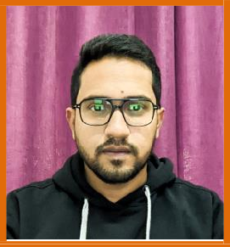
Name: Mr. Anuj Bhattacharya

Designation: Assistant Professor

Teaching Areas: Travel and Tourism Management
Aviation & Ticketing Cargo Handling Travel Documentation
E Tourism / IT in Tourism

Research Interests: Implementation of IT in Tourism
Augmented Reality and Virtual Reality in Tourism
Analysis of Digital Divide in Tourism

Education: BSc (Biotechnology) from Jiwaji University, Gwalior (MP)
Master in Tourism and Travel Management (MTTM) from IGNOU
PhD (Pursuing) in Travel and Tourism from Amity University, Noida (UP) | Thesis on: Impact of Digital Divide in Rural Tourism – A study of Sikkim

